|  |  |
| --- | --- |
| **COURSE / UNIT CODE:** ITECH2003 | **TUTOR NAME: Jaya Sharma** |
| **STUDENT ID: 30382027** | **STUDENT NAME: Abishkar Rai** |
| **DUE DATE:11 weeks** | **EXTENSION DATE AUTHORISED:** |
| **TITLE OF SUBMISSION:** Assignment 2 Programming | |

**PLAGIARISM**

Plagiarism is the presentation of the expressed thought or work of another person as though it is one's own without properly acknowledging that person. You must not allow other students to copy your work and must take care to safeguard against this happening.

Plagiarism is a serious offence. As set out in University Regulation 6.1.1., students who are caught plagiarising:

* A first offence, be given a zero mark for that task.
* A second offence will result in a failing grade for the Course(s) involved and,
* Any subsequent offence will be referred to the Student Discipline Committee.

Please read <http://policy.federation.edu.au/university/student_plagiarism/ch01.php>

**Declaration**

* I have read the university’s plagiarism policy and understand the consequences of engaging in plagiarism and collusion.
* I have taken proper care to safeguard this work and made all reasonable efforts to ensure it could not be copied.
* No part of this assignment has been previously submitted as part of another unit/course.
* I acknowledge and agree that the assessor of this assignment may for the purposes of assessment, reproduce the assignment and:
  + provide to another member of faculty and any external marker; and/or
  + submit it to a text matching software; and/or
* I certify that I have not plagiarised the work of others or participated in unauthorised collaboration when preparing this assignment.

**Note**: As this is an electronic submission, feel free to put your name in the signature box, you don't need to print / sign / scan this document.

Signature: Abishkar rai Date: 25/05/2020

This is assignment 2 of ITECH2003 is about build website (programming). So, this website name is ‘Abishkar Network solutions’ and it have 8 webpage with 5 global navigation & 3 local navigation. The contain of website will be networking, Active directory, Virtual Private Network, & more and webpage name are home page at first then Services where I put all three webpage about networking, active directory and vpn, next webpage experience, Photos, contact and about me. So, they are 8 webpage for the website.

Change which done after the webpage documentation

* Web page layout will be fixable with width will be 90% and the max- width is 960px. So, all webpage full work on Google Chrome.
* The background colour is changed into (#F8F8FF) Ghost White for better background colour.
* The home page knows as index.html image is changed into width 318px & height 159px.
* All the gallery images size is change in to width 297px & height 400px.

Test of the WebPages

Open at Google Chrome

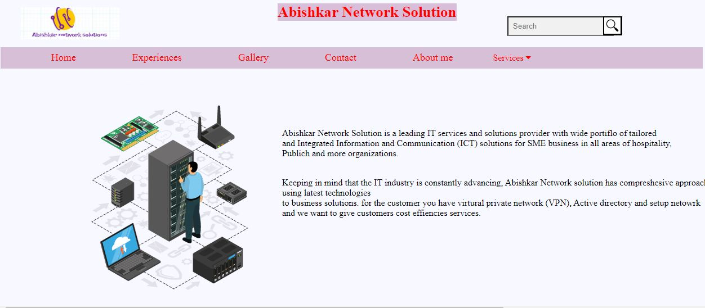

Open at windows internet explorer

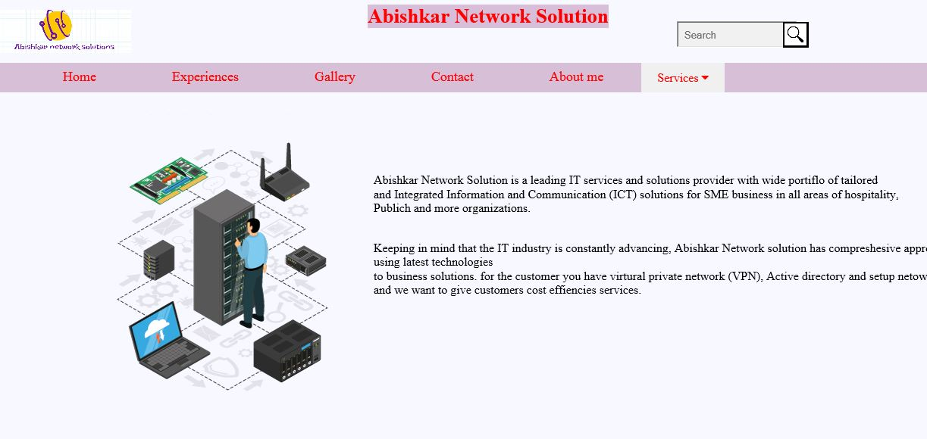

References

[www.w3schools.co](http://www.w3schools.co)m